## Project Report Template

# BUILD AN EVENT MANAGEMENT SYSTEM USING SALESFORCE

1. INTRODUCTION
   1. Overview

Event Management is the process of analyzing, planning, marketing, producing and evaluating an event. It is a different way of prompting a product, service or idea. If an event is managed efficiently and effectively, it can be used as a very powerful promotional tool to launch or market a product or service.

* 1. Purpose

Event Management is the process of creating and maintaining an event. This process spans from the very beginning of planning all the way to post event strategizing. At the start, an event manager makes planning decisions, such as the time, location, and theme of their event.

1. PROBLEM DEFINITION & DESIGN THINKING
   * 1. Empathy Map

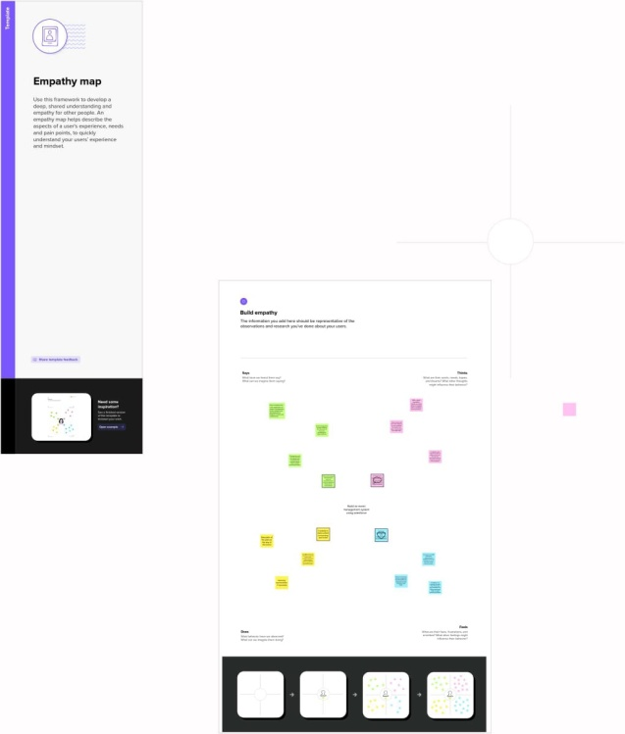

2.2 Ideation and Brainstorming

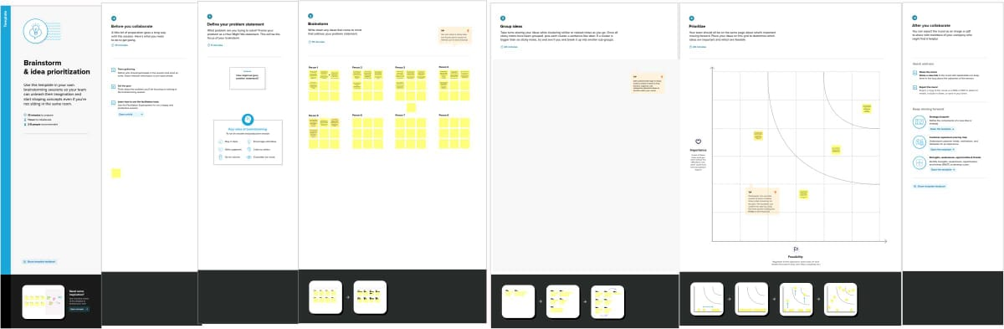

3) RESULT

3.1 Data Model:

|  |  |  |
| --- | --- | --- |
| Object Name | Fields in the Object | |
| Obj1  EVENT |  | |
| Field Label | Data Type |
| CITY | TEXT |
| START DATE | DATE\TIME |
| END DATE | DATE\TIME |
| EVENT NAME | MASTER DETAIL RELATIONSHIP |
| EVENT NAME | LOOK UP RELATIONSHIP |
|  |  |
| Obj2  ATTENDEES | Field Label | Data Type |
| PHONE | PHONE |
| ID | AUTO NUMBER |
| EMAIL | EMAIL |
| Obj3  SPEAKERS | Field Label | Data Type |
| BIO | TEXT AREA |
| EMAIL | EMAIL |
|  |  |
| Obj4  VENDORS | Field Label | Data Type |
| EMAIL | EMAIL |
| PHONE | PHONE |
| SERVICE PROVIDER | TEXT |
| EVENT NAME | LOOK UP RELATIONSHIP |
|  |  |
| Obj5  STUDENTS | Field Label | Data Type |
| TICKETS | PICK LIST |

3

.2 Activity and Screenshot

Milestone-1 (Creation of Salesforce Developer Org)

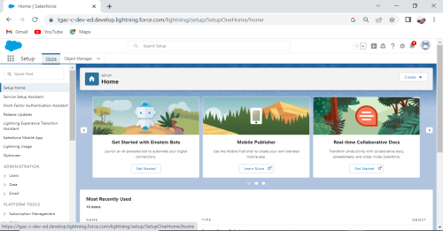

Milestone-2 (Object)

Activity-1 (Creation of object to Event Management)

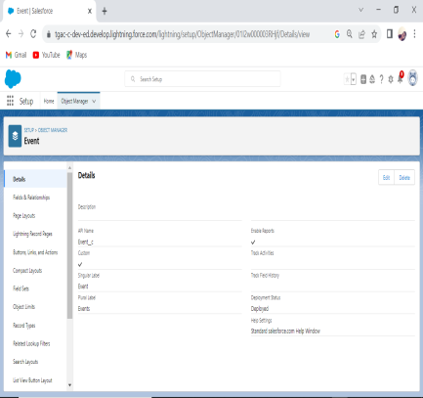

Activity-2 (Creation of Attendee Object)

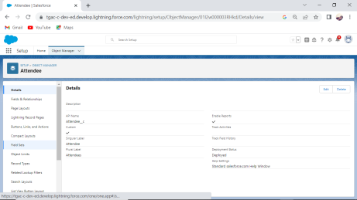

Activity-3 (Creation of Speaker Object)

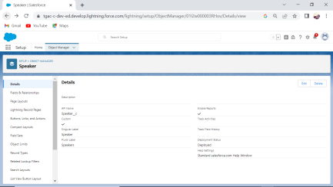

Activity-4 (Creation of Vendor Object)

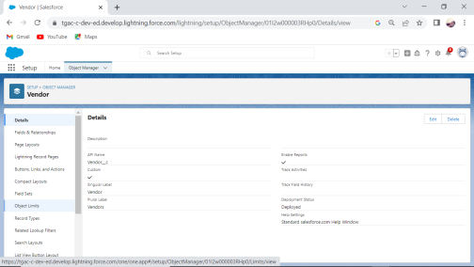

Milestone-3 (Tabs)

Activity-1 (Creation of Event Tab)

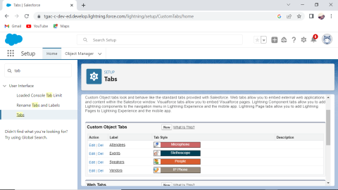

Activity-2 (Creation of Attendee Tab)



Activity-3 (Creation of Speaker Tab)



Activity-4 (Creation of Vendor Tab)

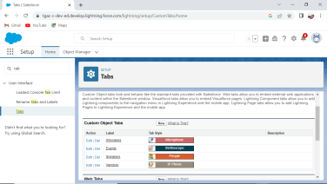

Milestone-4 (Applications)

Activity (Creating the Event Management Construction App)

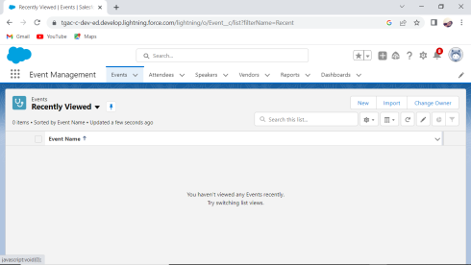

Milestone-5 (Fields)

Activity-1 (Creation of fields for Event Object)

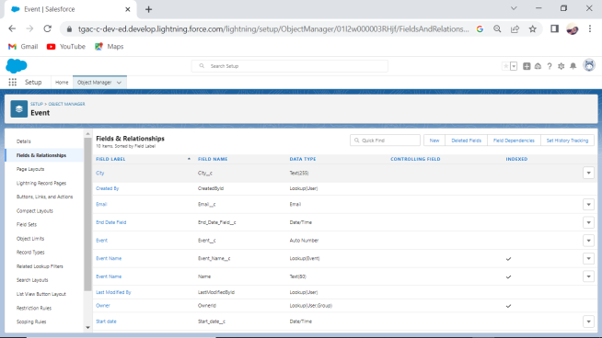

Activity-2 (Creation of fields for Attendees Object)

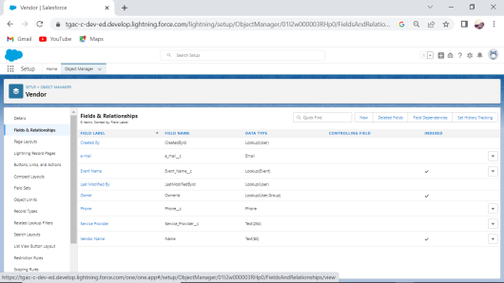

Activity-3 (Creation of fields for Speakers Object)

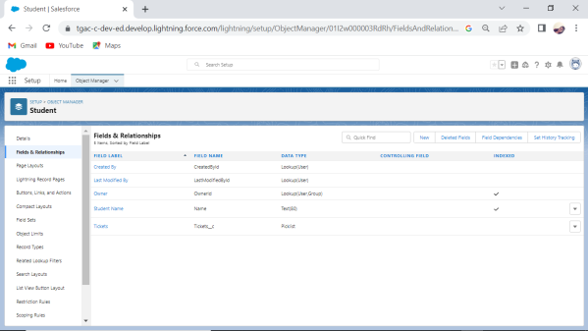

Activity-4 (Creation of fields for Vendors Object)

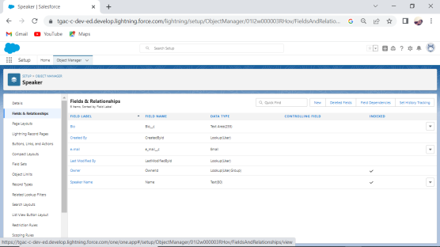

Milestone-6 (Profile)

Activity-1 (Creation of Profile)

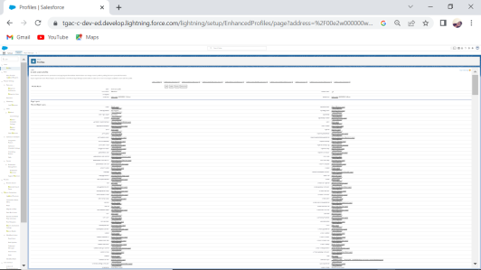

Activity-2 (Creation of Profile)

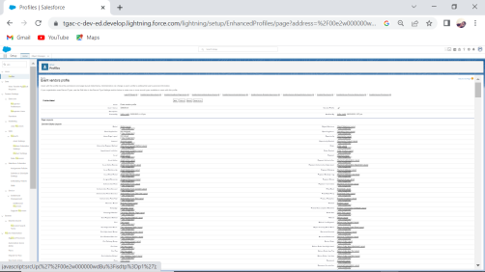

Milestone-7 (User)

Activity-1 (Creating a User)

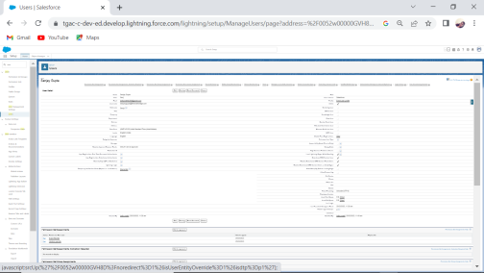

Activity-2 (Creating a User)

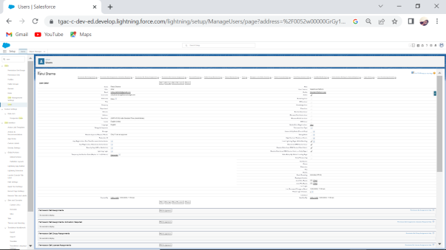

Milestone-8 (Permission Sets)

Activity-1 (Creating a Permission Set)

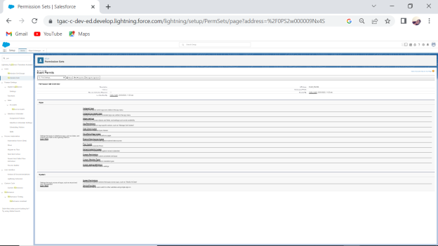

Activity-2 (Creating a Permission Set)

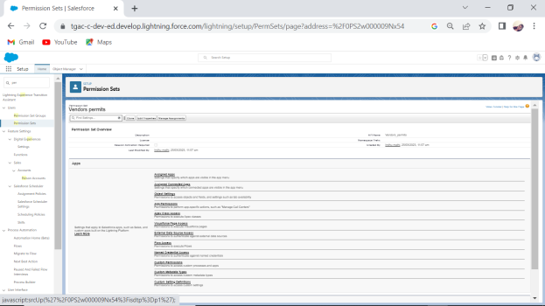

Milestone-9 (Reports)

Activity

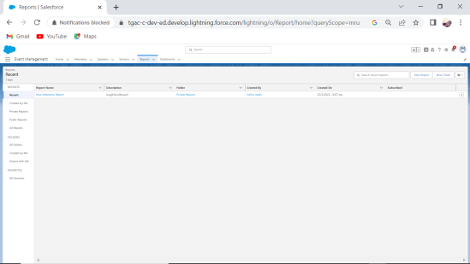

1. TRAILHEAD PROFILE PUBLIC URL

Team Lead – <https://trailblazer.me/id/manim127>

Team Member 1 - [https://trailblazer.me/id/iphysicsem](https://trailblazer.me/id/iphysicsem%20)

Team Member 2- <https://trailblazer.me/id/dhanu2412>

Team Member 3 -  [https://trailblazer.me/id/dhard174](%20https://trailblazer.me/id/dhard174)

Team Member 4 - <https://trailblazer.me/id/yogek15>

## Project Report Template

1. ADVANTAGES AND DISADVANTAGES

Advantages:

*They ensure it smoothly

*It minimizes the steps needed to manage the events, creating much more efficient administrative process

*It can reveal greater market trends

Disadvantages:

*Understaffing Problems

*Technological Challenges

*Unconventional working hours

1. APPLICATIONS

Event Management has wide range of applications such as

*Corporate event

*Wedding events

*Festivals and Cultural Events

*Sports events

*Fundraising Events

*Trade shows and exhibition

*Conventions and Meetings

7) CONCLUSION

* It generates the report on Event, Activity, Payment.

* Provide filter reports on Organizers, Attendees, Conductors.

* Application also provides excel export for Activity, Organizers, Conductors.

1. FUTURE SCOPE

* Analyzing today’s demand and awareness, it can be said that with more technological word in future and more dynamics in services industries, scope of event management is pretty good.

* If there won’t be any restriction or license game into establishing event companies, then it may happen that one day, event companies will be more than the total clients across nation.

* I know it sounds rubbish, but it’s a bitter truth! Nothing bad than this can happen to this industry.